 | VIVEKANANDHA COLLEGE OF ENGINEERING FOR WOMEN TIRUCHENGODE-637205 | 

UI & UX ASSIGNMENT -2

NAME: GAYATHRI T

REGISTER NO: 612923107013

DEPARTMENT: COMPUTER SCIENCE AND TECHNOLOGY

SUBJECT CODE & NAME: U23ITOE7 & Creative UX/UI Design

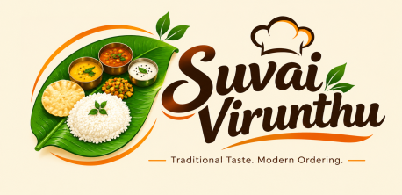

Online Food Ordering Interface Suvai Virunthu

1. Navigation Menu – Home, Menu, Offers and Contact
A professional navigation bar was created for the Suvai Virunthu website using HTML hyperlinks and buttons. It contains Home, Menu, Offers, Order, and Contact options. Each hyperlink navigates the user to the corresponding section of the same web page. An Order Now button is also provided for quick access to the order form.
HTML elements used: <nav>, <a>, buttons, and section IDs.

2. Food Categories Using Drop-down Menus and Tabs
A drop-down menu was created to allow customers to select different food items such as Idli, Dosa, Pongal, Biriyani, Parotta, Chicken 65, Payasam, Filter Coffee, and more. Four tabs were also provided to organize the menu into Breakfast, Main Course, Non-Veg Specials, and Desserts & Drinks.
HTML elements used: <select>, <option>, radio buttons, and CSS-based tabs.

3. Food Item Selection Using Checkboxes, Radio Buttons and Buttons
Each food card contains checkboxes for additional choices such as extra chutney, sambar, gravy, or papad. Radio buttons are provided for selecting options such as regular quantity or size. An Add to Cart button is also provided for every food item.
HTML elements used: <input type="checkbox">, <input type="radio">, and <button>.

4. Customer Order Form
A customer order form was created to collect the required delivery information. It includes text fields for customer name, phone number, email, city, and pincode, along with a textarea for delivery address and special instructions. Radio buttons are also provided to select the payment method such as Cash on Delivery, UPI, or Card.
HTML elements used: <form>, <label>, <input>, <textarea>, and radio buttons.

5. Order Summary Table
An order summary table was created to display the selected food items along with their quantity and price. Sample items such as Masala Dosa, Chicken Biriyani, and Filter Coffee are displayed in the table. The total order amount is also shown at the bottom of the table.
HTML elements used: <table>, <tr>, <th>, and <td>.

6. Accordion for Food Descriptions and Ingredients
An accordion section was implemented to display additional information about popular dishes. Customers can click on a food item to view its description and ingredients without occupying additional space on the page. Accordion entries were created for Idli, Masala Dosa, Chicken Biriyani, Parotta, and Payasam.
HTML elements used: <details> and <summary> with CSS styling.

7. Hover Effects and Suitable Page Elements
CSS hover effects and animations were added to improve the appearance and usability of the website. Navigation links, buttons, food cards, offers, and contact cards change their appearance when the user moves the mouse over them. Card lifting, shadows, color changes, and button animations provide a more attractive and interactive interface.
CSS features used: :hover, transition, transform, box-shadow, and animations.
8.CODE :
<head>
<meta charset="UTF-8">
<meta name="viewport" content="width=device-width, initial-scale=1.0">

<title>Suvai Virunthu | Indian Food Ordering</title>

<style>

/* =========================
GLOBAL STYLES
========================== */

* {
margin: 0;
padding: 0;
box-sizing: border-box;
scroll-behavior: smooth;
}

body {
font-family: Arial, Helvetica, sans-serif;
background: #FFF7E6;
color: #292929;
line-height: 1.6;
}

a {
text-decoration: none;
}

section {
padding: 70px 8%;
}

.section-title {
text-align: center;
font-size: 35px;
color: #1F1F1F;
margin-bottom: 10px;
}

.section-title span {
color: #F57C00;
}

.section-subtitle {
text-align: center;
color: #666;
margin-bottom: 40px;
}

/* =========================
NAVBAR
========================== */

.navbar {
position: sticky;
top: 0;
z-index: 1000;

min-height: 82px;
padding: 8px 6%;

background: #1F1F1F;

display: flex;
align-items: center;
justify-content: space-between;

box-shadow: 0 4px 15px rgba(0,0,0,0.25);
}

/* Logo */

.logo {
display: flex;
align-items: center;
min-width: 230px;
}

.logo img {
width: 210px;
height: 68px;
object-fit: contain;
object-position: left center;
display: block;

transition: 0.3s ease;
}

.logo img:hover {
transform: scale(1.04);
}

/* Navigation */

.nav-links {
display: flex;
align-items: center;
gap: 8px;
}

.nav-links a {
color: white;
padding: 11px 17px;
border-radius: 25px;

font-size: 15px;
font-weight: bold;

transition: 0.3s ease;
}

.nav-links a:hover {
background: #F57C00;
color: white;
transform: translateY(-2px);
}

.nav-order-btn {
background: #F57C00 !important;
color: white !important;
box-shadow: 0 4px 10px rgba(245,124,0,0.3);
}

.nav-order-btn:hover {
background: white !important;
color: #F57C00 !important;
}

/* =========================
HERO SECTION
========================== */

.hero {
min-height: 610px;

display: flex;
align-items: center;
justify-content: space-between;

gap: 40px;

background:
radial-gradient(circle at 10% 20%, rgba(255,183,77,0.25), transparent 25%),
#FFF7E6;

position: relative;
overflow: hidden;
}

.hero-content {
flex: 1;
animation: slideLeft 1s ease;
}

.hero-tag {
display: inline-block;

background: #FFB74D;
color: #1F1F1F

<head>
<meta charset="UTF-8">
<meta name="viewport" content="width=device-width, initial-scale=1.0">

<title>Suvai Virunthu | Indian Food Ordering</title>

<style>

/* =========================
GLOBAL STYLES
========================== */

* {
margin: 0;
padding: 0;
box-sizing: border-box;
scroll-behavior: smooth;
}

body {
font-family: Arial, Helvetica, sans-serif;
background: #FFF7E6;
color: #292929;
line-height: 1.6;
}

a {
text-decoration: none;
}

section {
padding: 70px 8%;
}

.section-title {
text-align: center;
font-size: 35px;
color: #1F1F1F;
margin-bottom: 10px;
}

.section-title span {
color: #F57C00;
}

.section-subtitle {
text-align: center;
color: #666;
margin-bottom: 40px;
}

/* =========================
NAVBAR
========================== */

.navbar {
position: sticky;
top: 0;
z-index: 1000;

min-height: 82px;
padding: 8px 6%;

background: #1F1F1F;

display: flex;
align-items: center;
justify-content: space-between;

box-shadow: 0 4px 15px rgba(0,0,0,0.25);
}

/* Logo */

.logo {
display: flex;
align-items: center;
min-width: 230px;
}

.logo img {
width: 210px;
height: 68px;
object-fit: contain;
object-position: left center;
display: block;

transition: 0.3s ease;
}

.logo img:hover {
transform: scale(1.04);
}

/* Navigation */

.nav-links {
display: flex;
align-items: center;
gap: 8px;
}

.nav-links a {
color: white;
padding: 11px 17px;
border-radius: 25px;

font-size: 15px;
font-weight: bold;

transition: 0.3s ease;
}

.nav-links a:hover {
background: #F57C00;
color: white;
transform: translateY(-2px);
}

.nav-order-btn {
background: #F57C00 !important;
color: white !important;
box-shadow: 0 4px 10px rgba(245,124,0,0.3);
}

.nav-order-btn:hover {
background: white !important;
color: #F57C00 !important;
}

/* =========================
HERO SECTION
========================== */

.hero {
min-height: 610px;

display: flex;
align-items: center;
justify-content: space-between;

gap: 40px;

background:
radial-gradient(circle at 10% 20%, rgba(255,183,77,0.25), transparent 25%),
#FFF7E6;

position: relative;
overflow: hidden;
}

.hero-content {
flex: 1;
animation: slideLeft 1s ease;
}

.hero-tag {
display: inline-block;

background: #FFB74D;
color: #1F1F1F

9.OUTPUT :
SCREEN SHOTS ARE ATTACHED HERE:
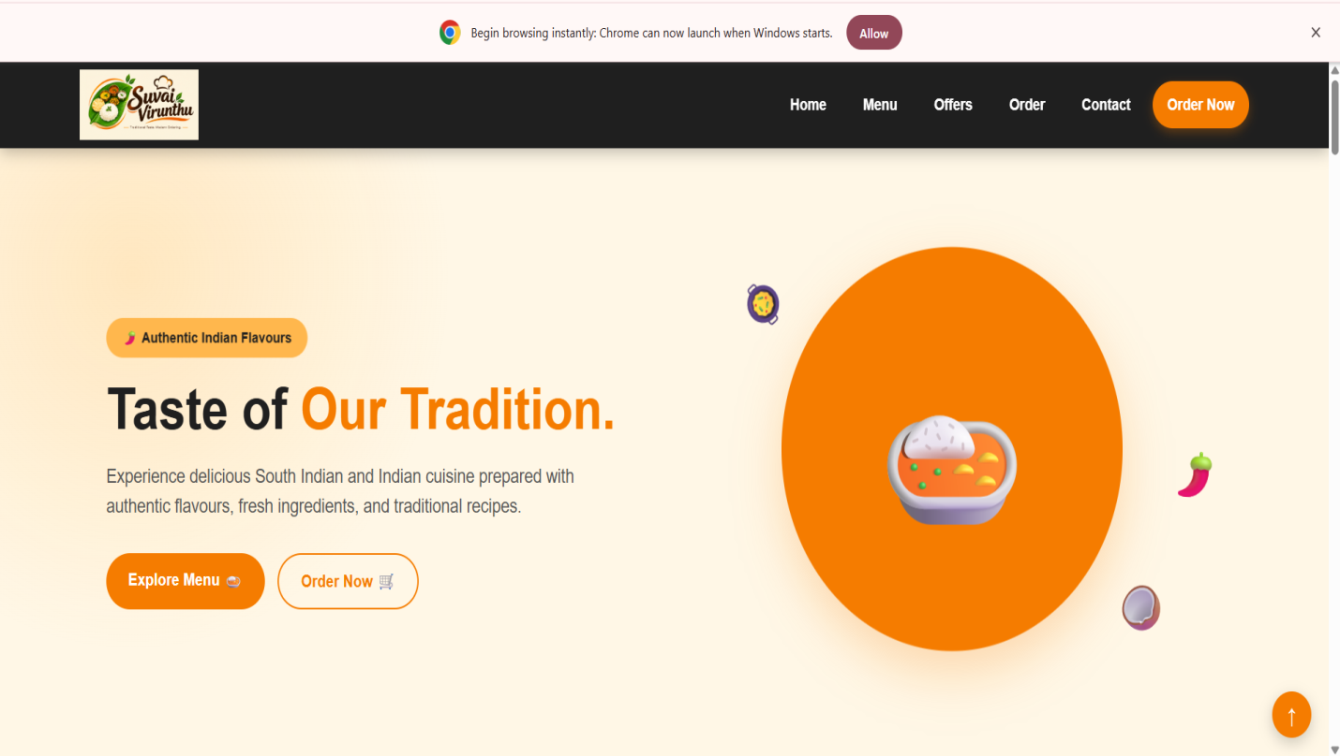

MENU PAGE: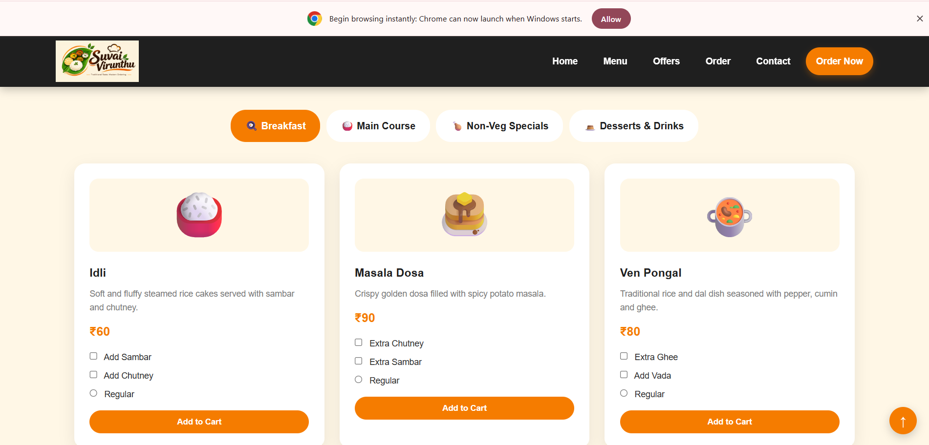

INGREDIENTS PAGE:
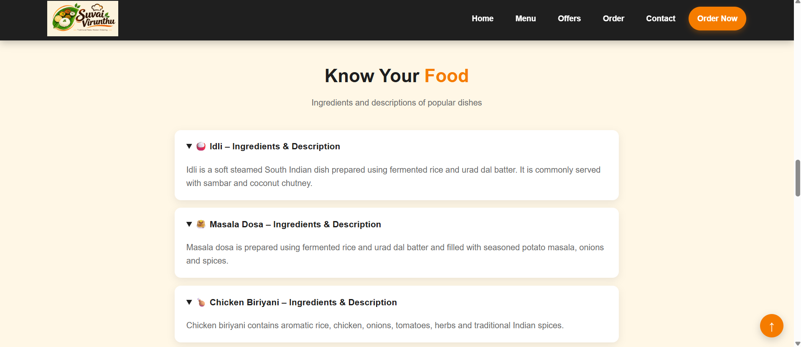

PLACE YOUR ORDER:
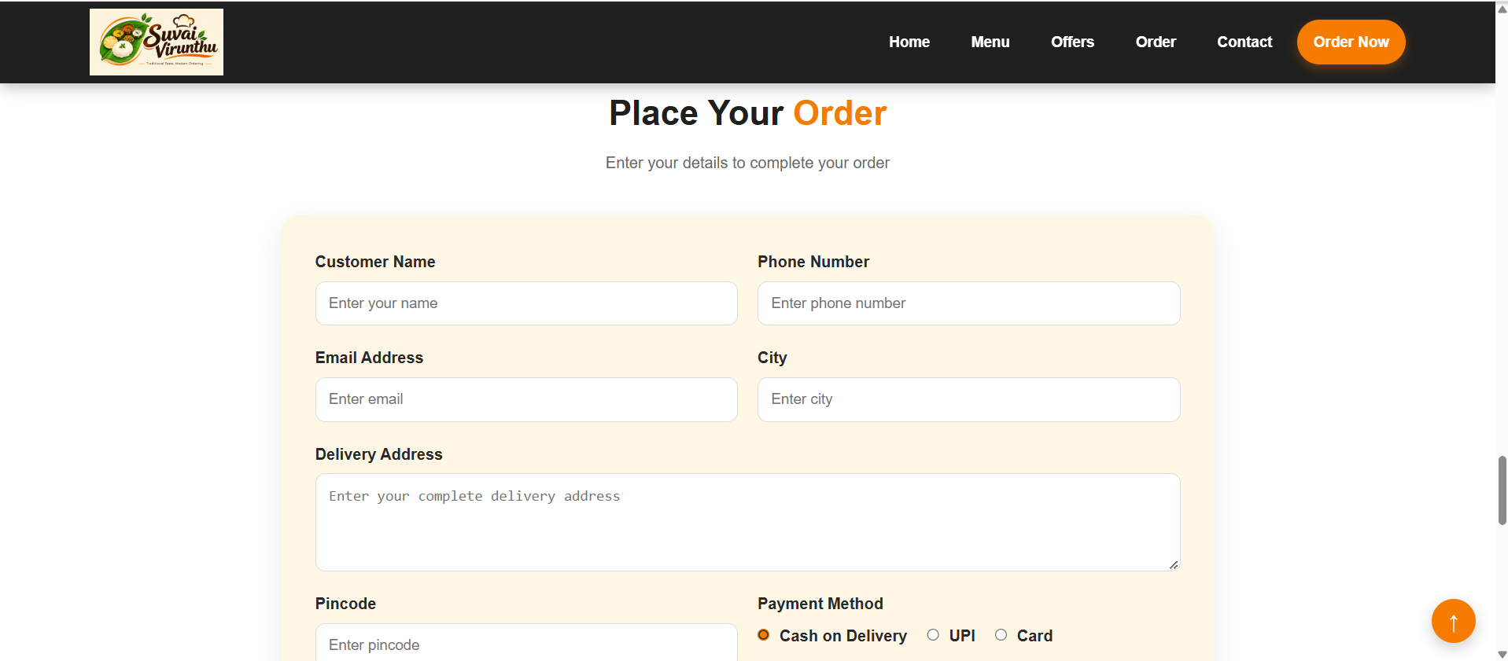

10.CONCLUSION:
The Suvai Virunthu Online Food Ordering Interface was developed using HTML and basic CSS. The website demonstrates navigation menus, hyperlinks, dropdown lists, tabs, checkboxes, radio buttons, buttons, forms, tables, accordions, hover effects, animations, and responsive design in a single user-friendly food ordering interface.

